MICRO GOALS -SECURE GOAL MANAGEMENT BACKEND

TEAM ID: SWTID-2026-8436 TEAM SIZE: 4
TEAM LEADER: PRITHINKIRA
EMAILTEAMEMEBERS:prithinyankara24@gmail.com
NAME: VIKASH.S
EMAIL:vikash8124@gmail.com
NAME: ROSHAN R
EMAIL:gibeyonroshan@gmail.com
NAME: SUNIL KUMAR S
EMAIL : sunilkumarsettu2020@gmail.com

Project Overview:
MicroGoal is a secure backend RESTful API developed using Node.js, Express.js, and MongoDB.
It enables users to register, log in, and manage their personal goals through CRUD operations.
The system uses JWT authentication and
middleware to ensure data security and user- specific access control.
The system includes:
- User Registration & Login
- JWT-based Authentication
- CRUD Operations for Goals
- Protected Routes
- Centralized Error Handling
The main objective is to provide a secure and scalable backend system for digital goal
management.

Project Instruction:
  - The project follows REST API principles.
  - Authentication is handled using JWT.
  - MongoDB is used as the database.
  - APIs are tested using Thunder Client.
  - The project follows MVC architecture.

Pre-requisites
Before running the project, the following tools are required:
  - Node.js (v18 or higher)
- Express.js
  - MongoDB (Local / Atlas)
  - VS Code
  - Thunder Client (Extension)
- Basic knowledge of JavaScript & REST APIs

PROJECT ARCHITECTURE: TECHNICAL ARCHITECTURE:
  - Runtime: Node.js
  - Framework: Express.js
  - Database: MongoDB
- Authentication: JWT
  - Architecture Pattern: MVC

FEATURES
- User Registration
  - Secure Login with JWT
  - Create Goal
  - Update Goal
  - Delete Goal
  - View User-specific Goals
  - Protected Routes
  - Centralized Error Handling

PROJECT SETUP AND CONFIGURATION:
Folder Structure :
MicroGoals middleware
authMiddleware.js errorMiddleware.js Schema
User.js
GoalSchema.js models userModel.js goalModel.js routes
authRoutes.js goalRoutes.js env
Index.js
package.json

Project Setup
- npm init -y
- Install dependencies: npm install express mongoose jsonwebtoken bcryptjs dotenv
- Start server: node server.js

DATABASE DEVELOPMENT CONFIGURE
MongoDB

  - Use MongoDB Atlas or Local MongoDB
  - Store connection string in .env

CREATE DATABASE CONNECTION
Index.js file:
- Use mongoose.connect()

PROJECT EXECUTION
Project Execution Steps
- Start MongoDB
- Run server
- Test APIs in Thunder Client
- Register User
- Login and get JWT
- Perform CRUD operations

Project Output Screenshots:
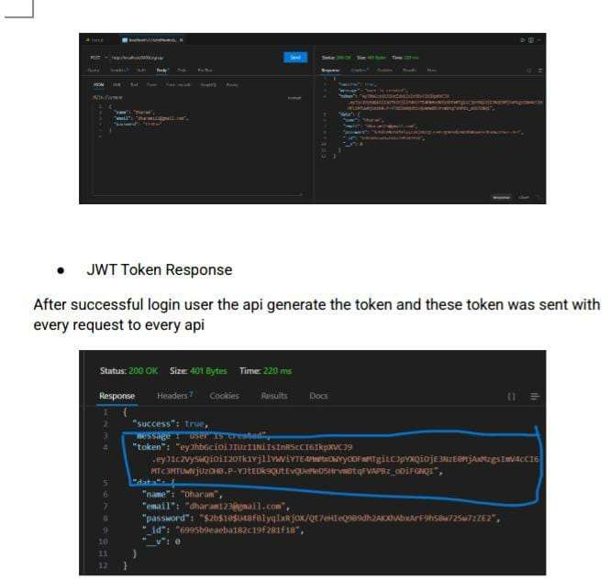

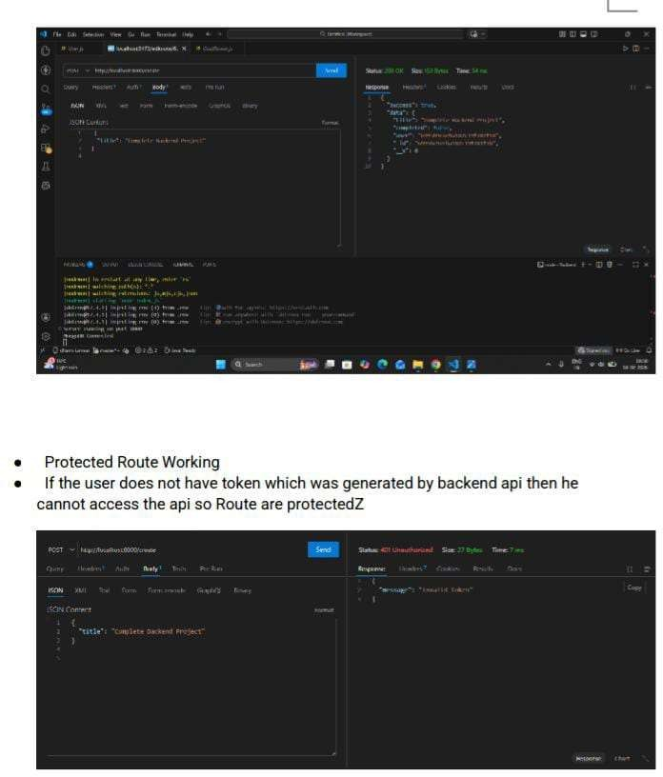

DRIVE LINK( FOR PHASES)
https://drive.google.com/drive/folders/1lHGWxJRXsPjo7AkDkrTu51cN1KRqBv5 c?usp=sharing

